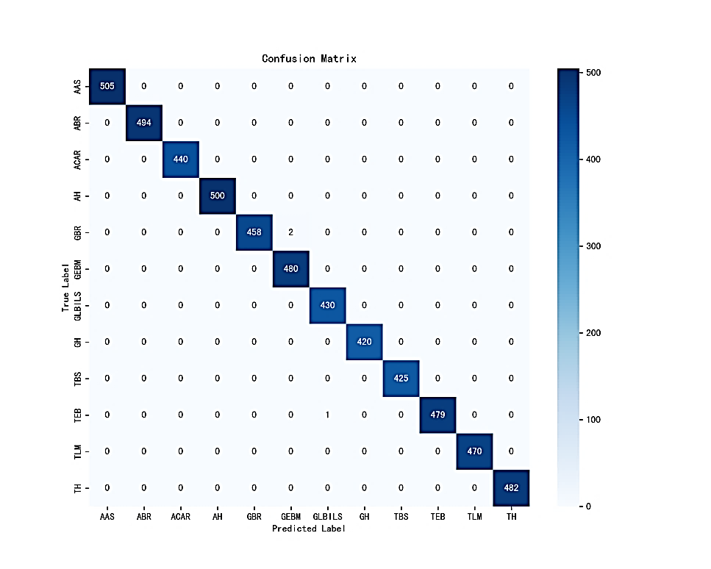
Figure 4.5 Confusion Matrix

